**Analysis of the excited energy-states of *cis-*β-Apo-8’-carotenal using   
time-resolved absorption spectroscopy**

Kota Horiuchi1, Chiasa Uragami1, Taiki Inoue1, Nao Yukihira1,

and Hideki Hashimoto1*

*1 Department of Applied Chemistry for Environment, School of Science and Technology,*

*Kwansei Gakuin University, 2-1 Gakuen, Sanda, Hyogo 669-1337, Japan.*

**1. Introduction**

β-Apo-8’-carotenal is one of the carotenoids that has a carbonyl group coupled to its polyene backbone and has nine conjugated C=C double bonds. The light energy that is captured by carotenoids is transferred to chlorophylls in order to initiate photosynthetic light reaction. When carotenoids absorb photons, they are excited up to the second excited singlet state (S2 state) from the singlet ground state (S0 state). However, it is recognized that carotenoids with carbonyl group generate the ICT (Intramolecular Charge Transfer) excited state [1]. The ICT excited state is an excited energy-state that is very important to improve the efficiency of excitation energy-transfer from carotenoid to chlorophyll. It is confirmed that all-*trans*-β-Apo-8’-carotenal (see **Figure 1** for its chemical structure) generates the ICT excited state following photoexcitation when it is dissolved in polar organic solvents [1]. In this study, we focused on the ICT excited state of *cis*-β-Apo-8’-carotenal. We isolated *cis*-isomers of β-Apo-8’-carotenal that were produced by photoisomerization and applied them femtosecond time-resolved absorption spectroscopic studies.

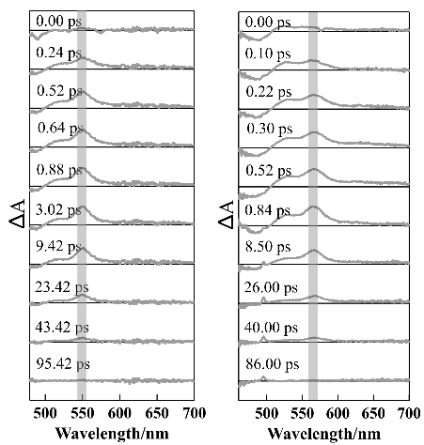

S1→SN transition

**Figure 1.** Chemical structure of all-*trans*-β-Apo-8’-carotenal

**2. Experimental**

To obtain *cis*-isomers of β-Apo-8’-carotenal, we applied photoisomerization of the all-*trans* isomer using iodine as a catalyst. 13’- and 9-*cis* isomers were isolated and purified by means of HPLC [2]. We dissolved 13’-*cis-*β-Apo-8’-carotenal in polar and nonpolar solvents (acetone, methanol, and *n*-hexane) and 9-*cis-*β-Apo-8’-carotenal in *n*-hexane. We recorded femtosecond transient absorption spectra of these *cis*-isomers.

**3. Results and Discussion**

We found that the 13’-*cis­* isomer in polar solvent generates the ICT excited state as has similarly been exemplified by the all-*trans* isomer. In the case of 9-*cis*-isomer, the steady-state absorption exists at the shorter wavelength region than that of the all-*trans* isomer. However, as shown in **Figure 2**, the transient absorption band that represents S1→SN transition of 9-*cis* isomer in *n*-hexane is redshifted compared with that of the all-*trans* isomer. From this observation, it is suggested that the energy gap between S2 and S0 in the 9-*cis* isomer is larger than that of all-*trans*, but the gap between S1 and SN in 9-*cis* is smaller than all-*trans*.

**Figure 2.** Femtosecond time-resolved absorption spectra of all-*trans* and 9-*cis*-β-Apo-8’-carotenal in *n*-hexane at room temperature

[1] M. Durchan, M. Fuciman, V. Slouf, G. Kesan, T. Polivka, *J. Phys. Chem. A,* **116** (2012) 12330-12338.

[2] H. Hashimoto, Y. Miki, M. Kuki, T. Shimamura, H. Utsumi, Y. Koyama, *J. Am. Chem. Soc*. **1993**, 115, 9216−9225.